COMPUTER VISION
MAINAK DUTTA
IRO2017009

Parallel to Perspective projection

We project the image from parallel to perspective by changing. We just change the camera position from above the bench to the side of the bench. If we take co ordinate system at the plane of the bench , so we take z axis at the upper direction in the perpendicular of the bench. Let, the height of the camera from the bench is H.
Let the length of the bench corresponds to X axis and width of the bench Y axis. The length of the of the bench is L.
So, we convert the axis to one edge by translating on X axis by L/2.
And then we convert the camera to the plane of the bench by translating Z axis by -H.

And by need to convert the angle of the camera along z axis by 90 degree in anti-clockwise direction because camera was previously parallel will now be perpendicular to the plane.
Rotation Matrix by rotation along z axis.

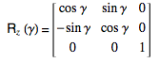
Homogeneous Transformation Matrix,

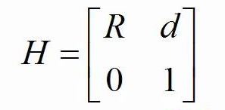

R = sin90 cos90 0 L/2
-sin90 cos90 0 0
0 0 1 -H
0 0 0 1

If we apply the camera projection rotation matrix with the input image, we will get the output image and also the perspective projection.

Input:

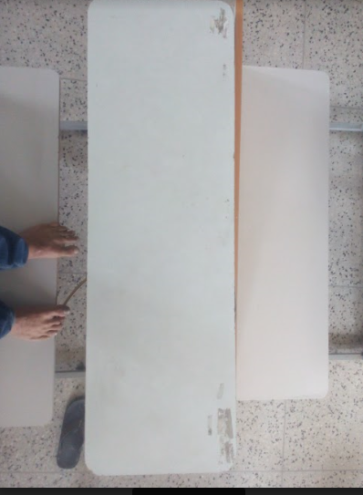
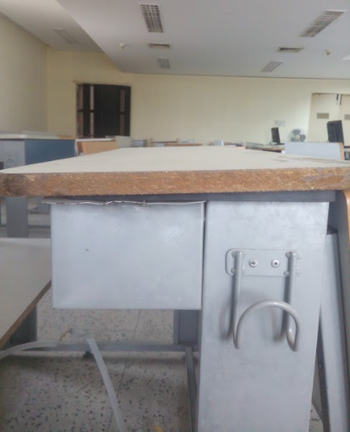

OUTPUT PROJECTION MATRIX:

sin90 cos90 0 L/2
-sin90 cos90 0 0
0 0 1 -H
0 0 0 1

